Crisis Response Module 2: Crisis Communication Bot

Hands-on Lab Step-by-Step

August 2020

Contents

Lab Prerequisites 1

Crisis Communication Bot 1

Exercise 1: Sign up for PVA and build the bot 2

Task 1: Sign up for PVA 2

Task 2: Create topics 6

Task 3: Test topics 9

Task 4: Change the greeting 11

Task 5: Publish the bot 13

Copyright 16

## Lab Prerequisites

Power Apps license and an environment.

# Crisis Communication Bot

The module will help you quickly build a bot using Power Virtual Agents to manage crisis response FAQ’s and get information out quickly in a chat interface that can be embedded in any website.

* Sign up for trial Power Virtual Agents.
* Build a bot using FAQ’s
* Test the bot
* Change the default greeting
* Publish the bot

Estimated time to complete these steps: **15–20 minutes**.

# Exercise 1: Sign up for PVA and build the bot

In this exercise, you will sign up for Power Virtual Agents trial, create a bot, build topics from the CDC FAQ site, and test the bot.

## Task 1: Sign up for PVA

In this task, you will sign up for Power Virtual Agents trial. If you already completed module S03 – Power Virtual Agents, then you can skip to step 9.

1. Navigate to [Power Virtual Agents](https://powerva.microsoft.com/)
2. Scroll down and click **Sign up**.

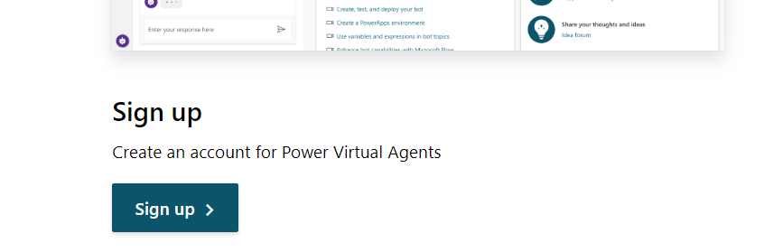

1. Provide your admin email address and click **Sign up**.

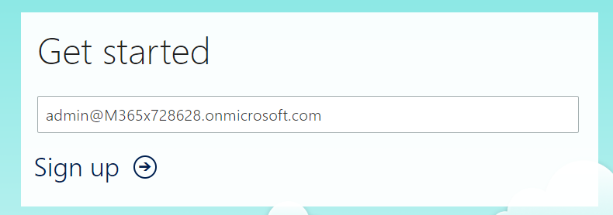

1. Click **Sign in**.
2. Provide your password and click **Sign in** again.
3. Click **Create** and wait until you see the sign in button.

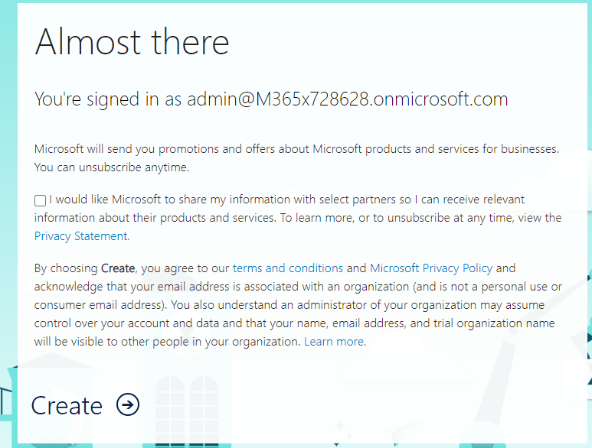

1. Click **Sign in**.

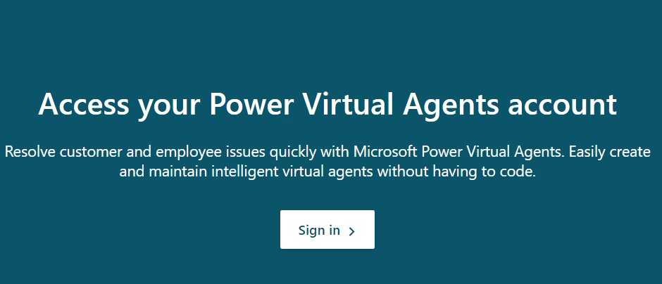

1. Select your country/region and click **Get Started**.

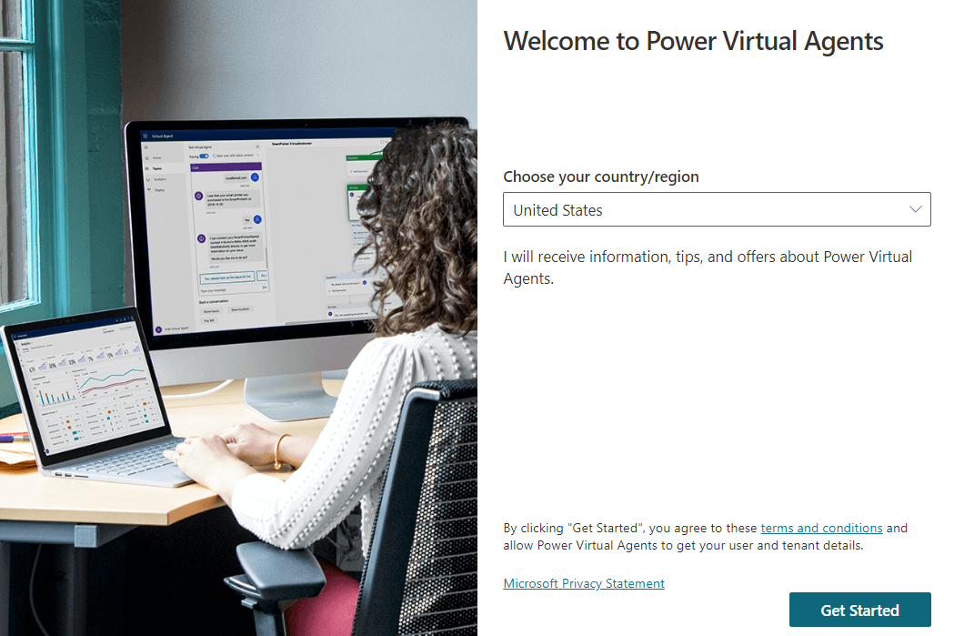

1. If you already have a Power Virtual Agents trial and have used this trial to create a bot in the past, then sign in to [Power Virtual Agents](https://powerva.microsoft.com/#/) and select the bot symbol.

Select bot symbol - screenshot

1. Select **+New Bot.**

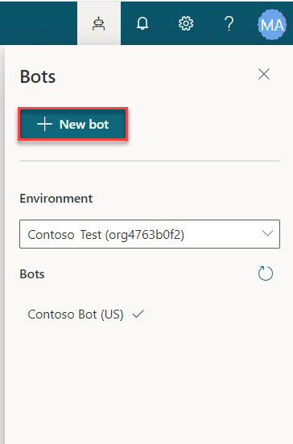

1. Enter **Crisis Bot** for name, select the environment you want to create the bot in, select a language, and click **Create**. Wait for the bot to be created.

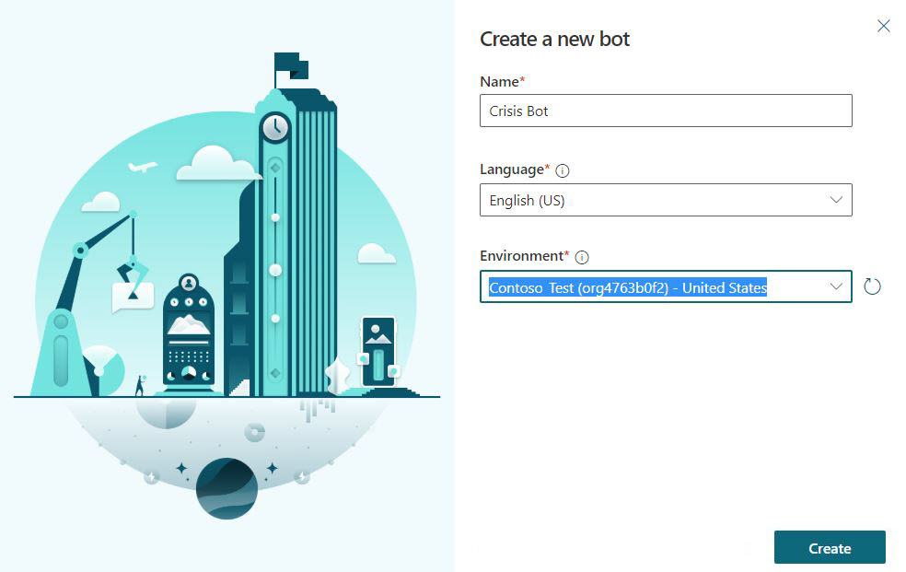

1. Click **Explore bot**.

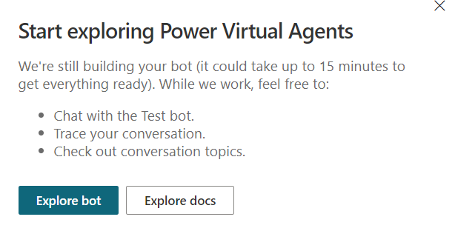

1. Test the Bot. Type **Hello** in the message box and click **Send**. The Bot should greet you and tell you what it can do.

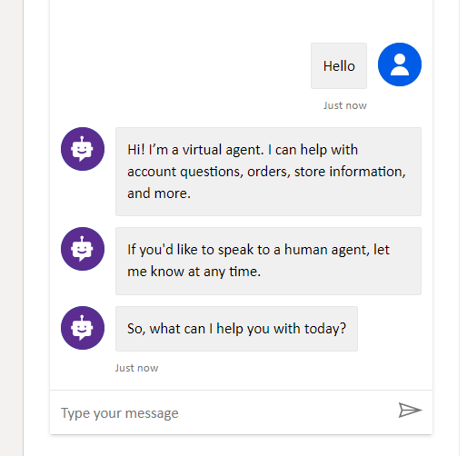

1. Close the **Chat**.

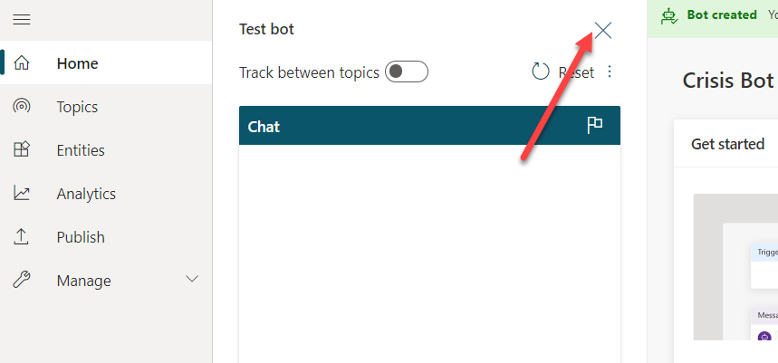

1. Select **Topics**. The bot comes with some sample user topics and some system topics. The default greeting came from the system topics.

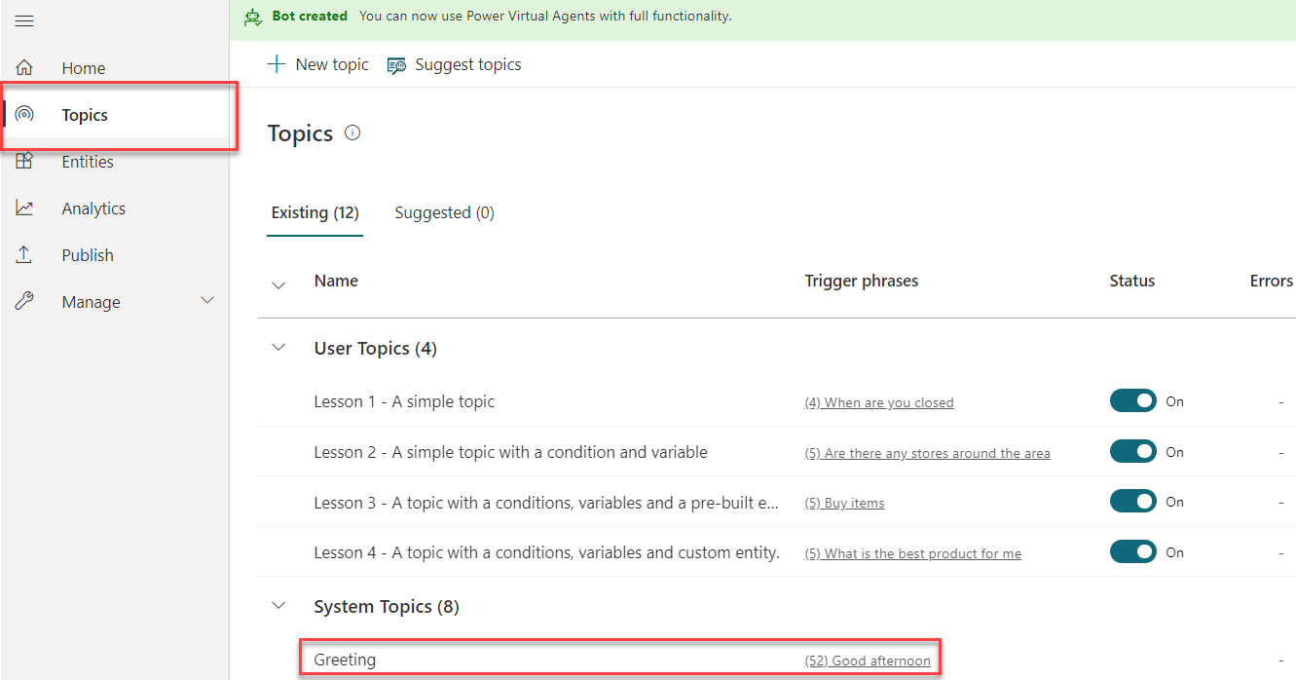

1. In the next task, you will generate your own topics from the CDC FAQ site. Do not navigate away from this browser window.

## Task 2: Create topics

In this task, you will generate topics from the CDC FAQ site.

1. Navigate to [CDC FAQ](https://www.cdc.gov/coronavirus/2019-ncov/faq.html) site and examine what is on the site. You will generate your topics from these FAQs
2. Copy the URL.

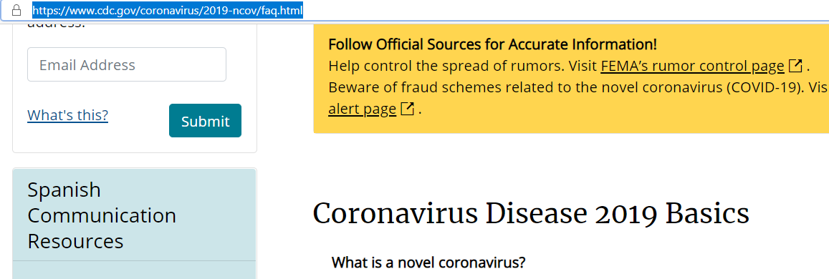

1. Go back to Power Virtual Agents and make sure you still have **Topics** selected.
2. Select the **Suggested** tab.

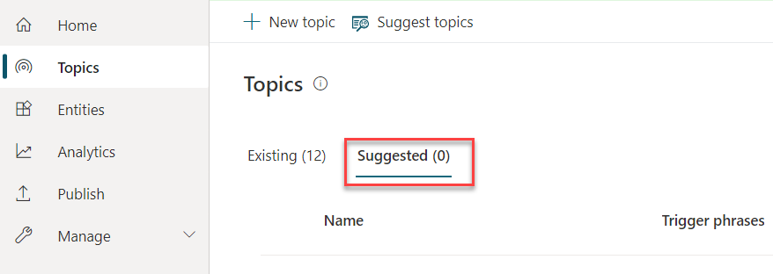

1. Click **Get started.**

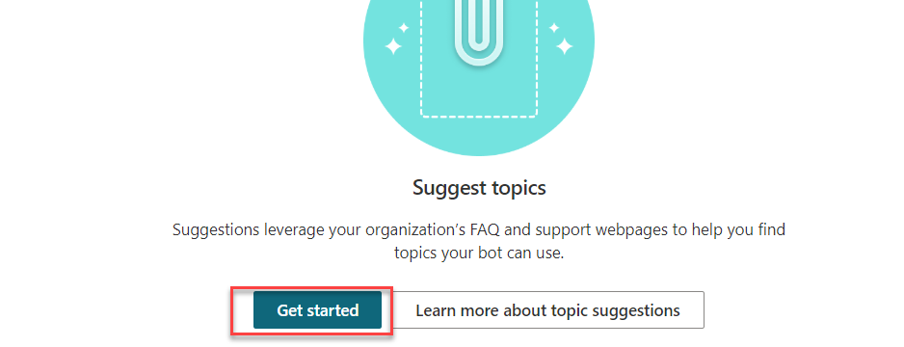

1. Paste the URL you copied in the **Web link** textbox and click **Add**.

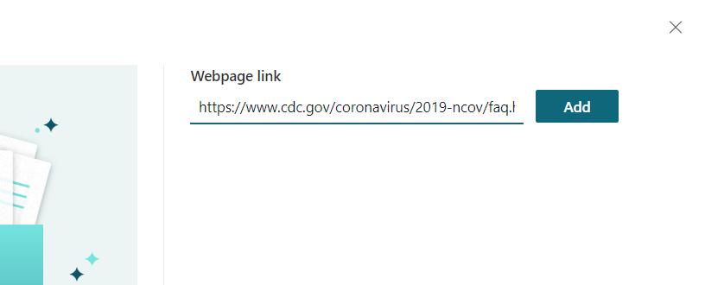

1. Click **Start** and wait. This can take few minutes.

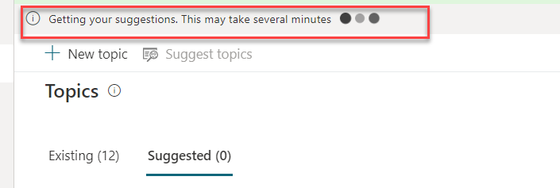

1. You should get some suggested topics created for you.

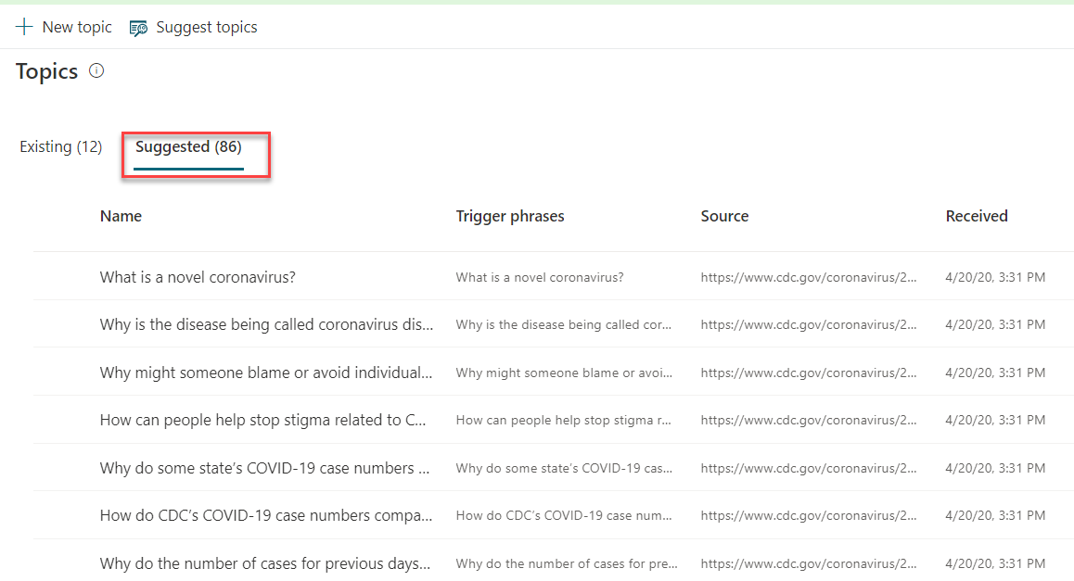

1. Click to open one of the suggested topics.

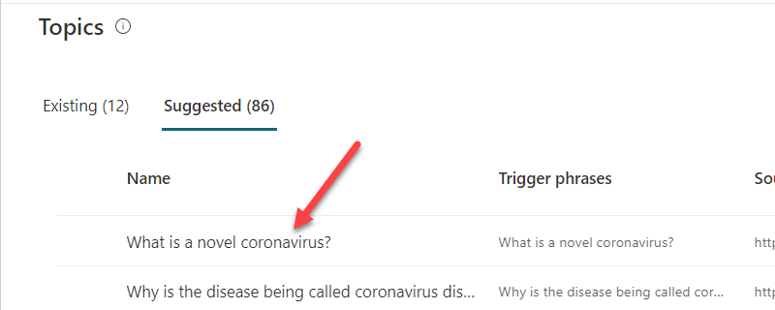

1. You should see the trigger phrase and what the bot reply will be. **Click Add to topics.**

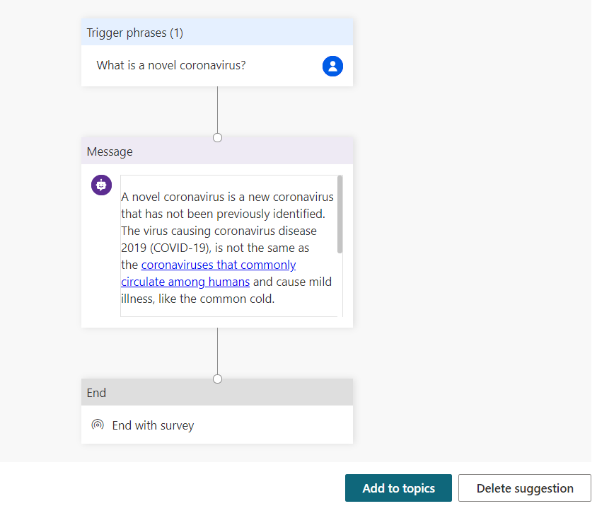

The suggested topic should be added to your topics. Select all the suggested topics and click **Add to topics**. 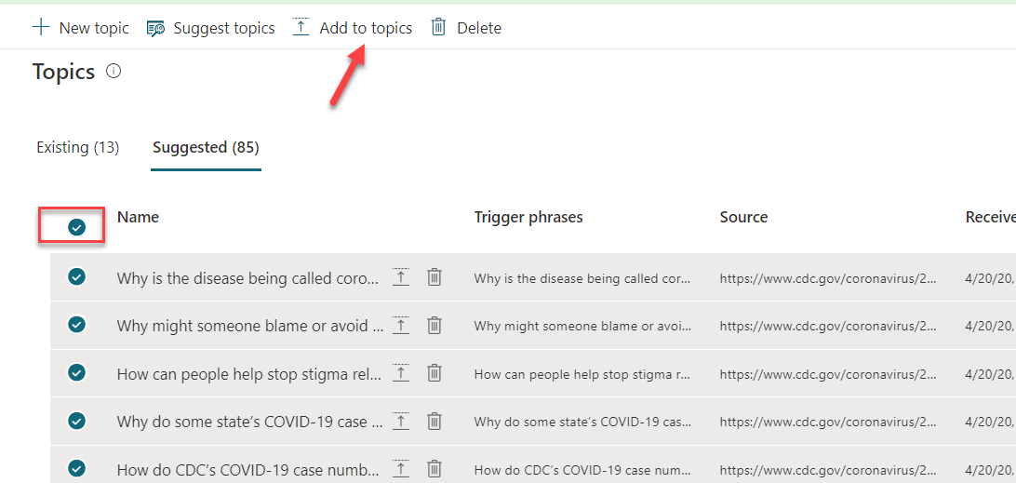

1. Select the Topics tab. You should see the new topics with their status set to Off.

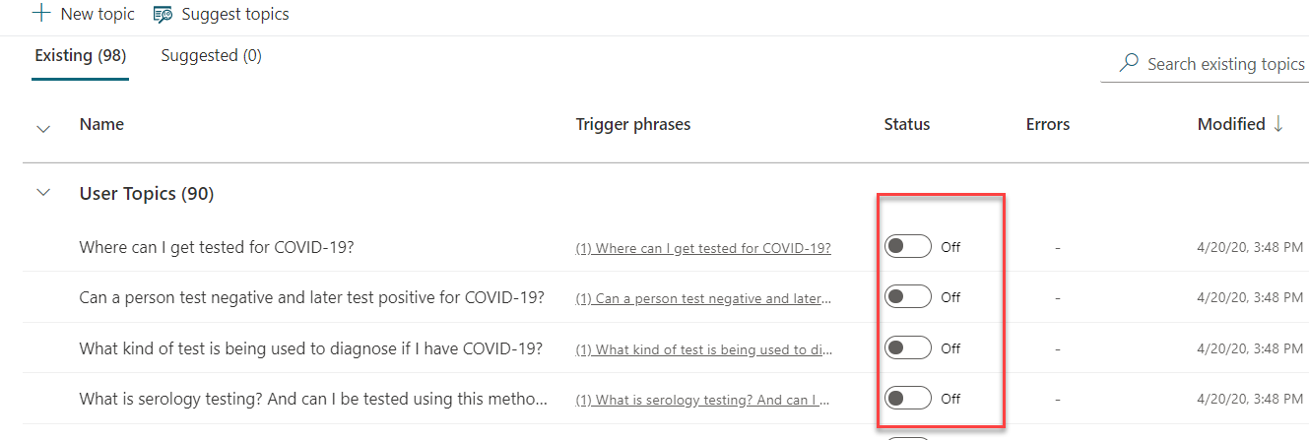

1. Click on the toggle button of the status column to turn them all on. If you are short on time, you may turn on the first ten, but ensure you’ve turned “**How can I protect myself**” to On.

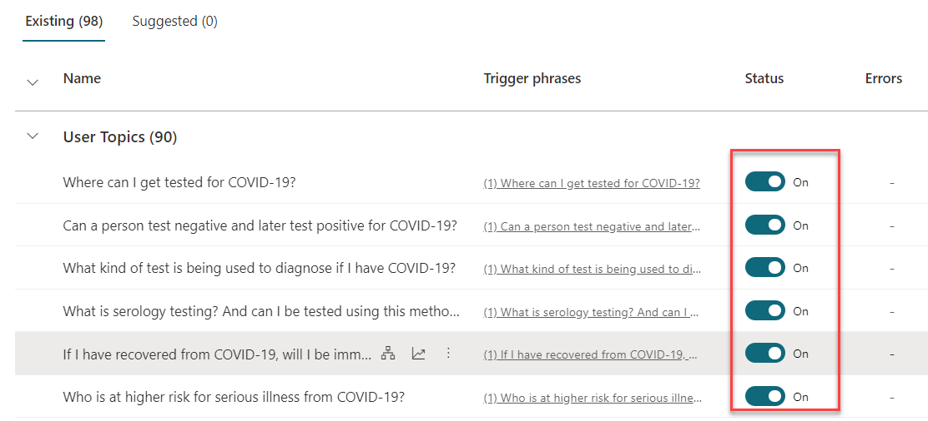

1. Do not navigate away from this browser window.

## Task 3: Test topics

In this task, you will test the topics you added.

1. Click **Test your bot.**

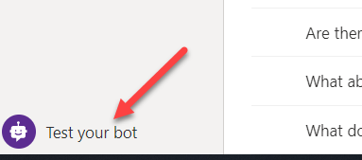

1. Click **Reset**.

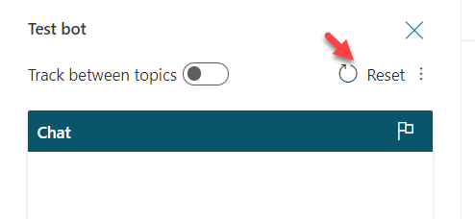

1. Type **How can I protect myself?** And click Send.

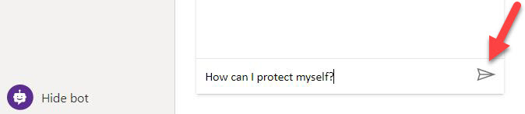

1. The bot should give you the correct information and ask if it answered your question. Click **Yes**.

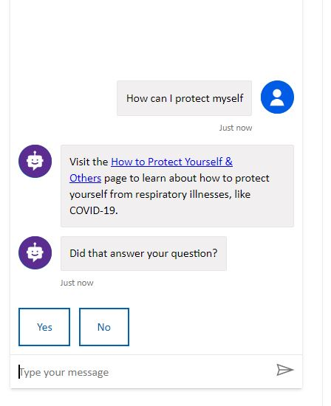

1. The bot should ask you the rate how it did. Give it an excellent rating.

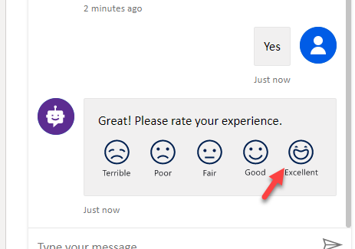

1. The bot should ask if it can help you with anything else. Click **No, Thanks**.
2. The bot should conclude the chat session.
3. Type **hello** and click **Send**.
4. The bot should greet you and tell you what it can do. Your bot can now help users with Covid-19 FAQs, you will change the greeting message in the next task. Do not navigate away from this browser window.

## Task 4: Change the greeting

In this task, you will change the greeting to Covid-19 specific.

1. Make sure you have **Topics** selected and select the **Existing** tab.
2. Collapse the **User Topics** section.

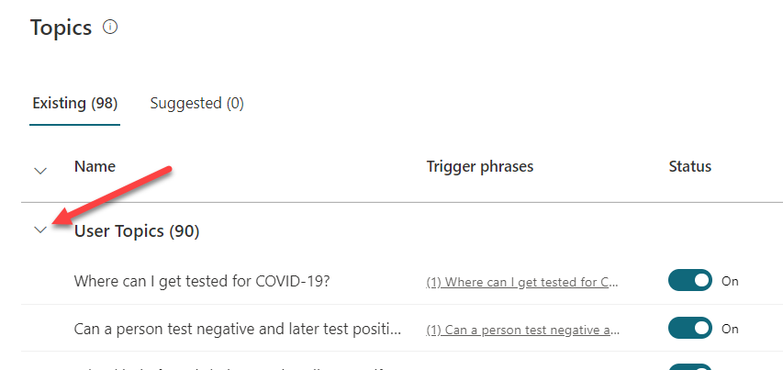

1. Click to open the **Greeting** topic of the System Topics.

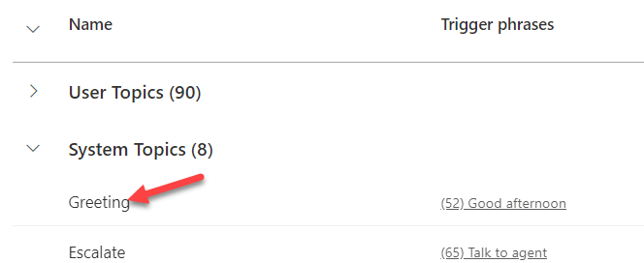

1. The greeting topic has 52 trigger phrases, click **Go to authoring canvas**.

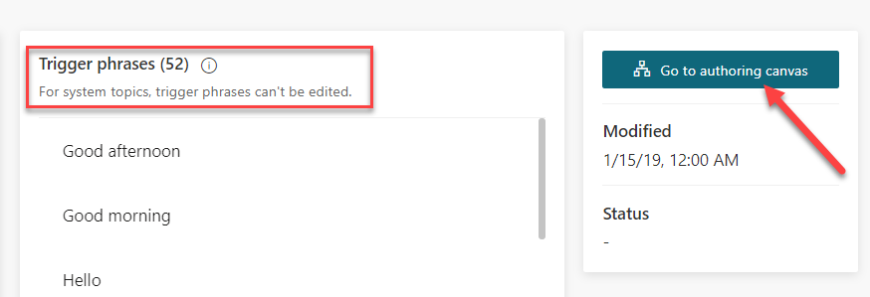

1. Go to the first message and replace it with **Hi, I’m a virtual agent. I can tell you about how COVID-19 spreads, how to protect yourself, preparing your home and family for COVID-19, symptoms, testing, and more.**

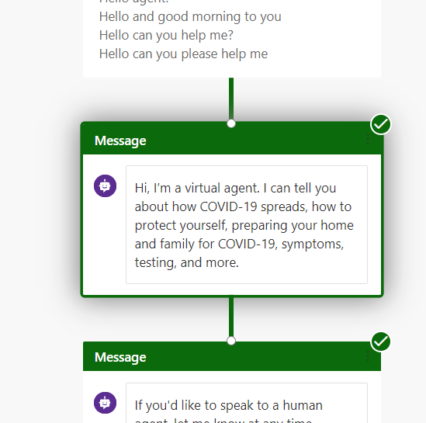

1. Click **Save**.

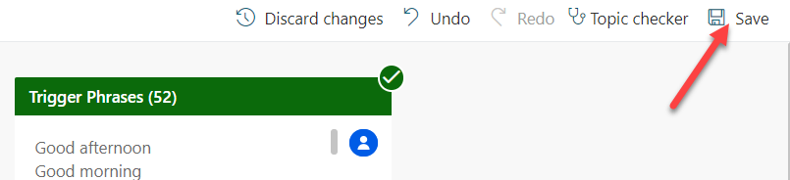

1. Click **Test Bot**  and then Click **Reset** to reset the chat.
2. Type hello and click **Send**.
3. The bot should now reply with correct information.

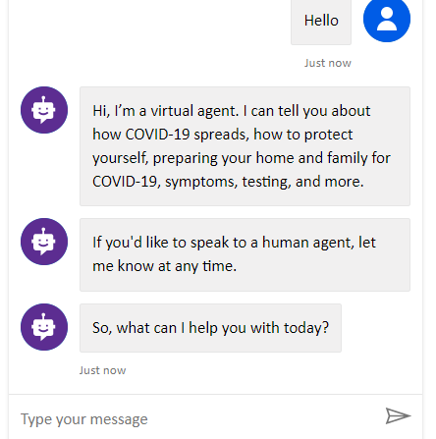

## Task 5: Publish the bot

In this task, you will publish the bot.

1. Select Publish.

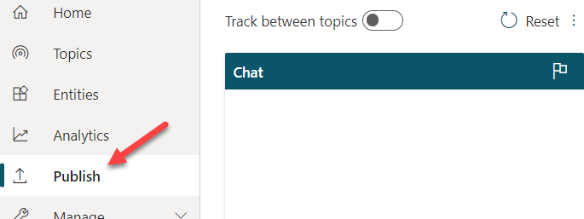

1. Click **Publish**.

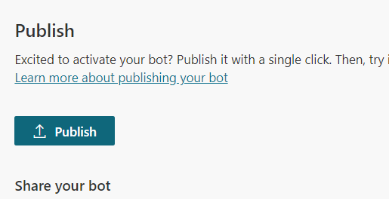

1. Click **Publish** again and wait for the publishing to complete.
2. Expand **Manage** and select **Channels**.

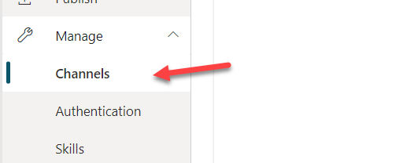

1. You will get list of available channels you can publish your bot to. Select **Demo website**.

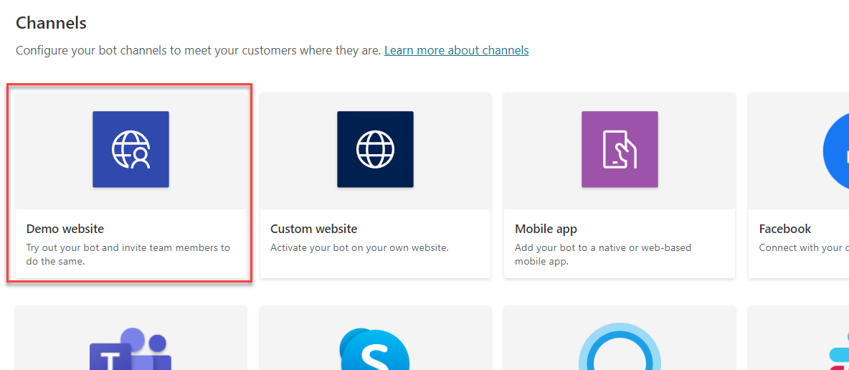

1. Change the welcome message to **Try my COVID-19 FAQ bot.**
2. Enter “Who is at higher risk for serious illness from COVID-19”, “What does more severe illness mean” and “What is CDC doing about COVID-19” for conversation starters and click **Save**.

Note that if you skipped turning all of the topics to On that you may need to find different trigger phrases as the phrase must be turned on for the Bot to recognize the topic.

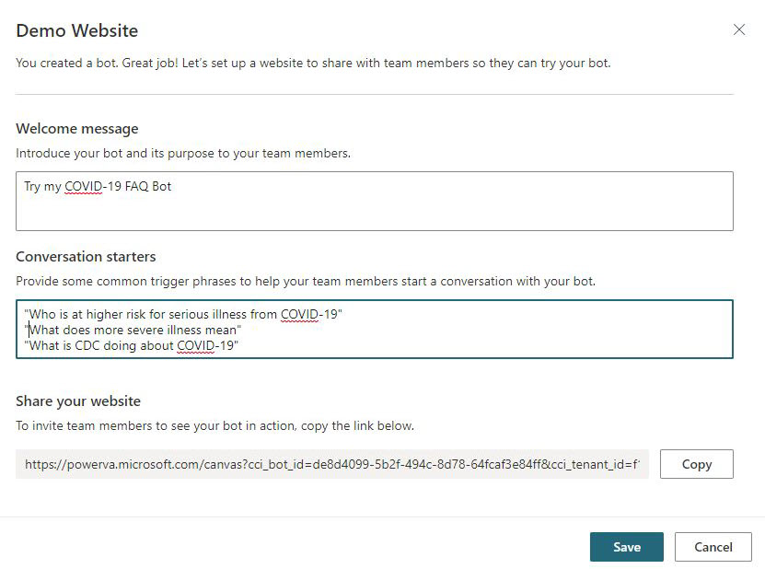

1. Copy the **URL**.

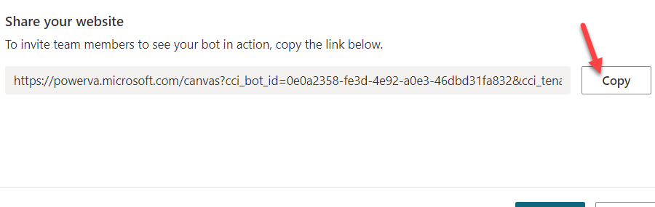

1. You can share the URL with your colleagues and get feedback from them. Start a new browser window or tab and navigate to the URL you copied. The demo website should like the image below.

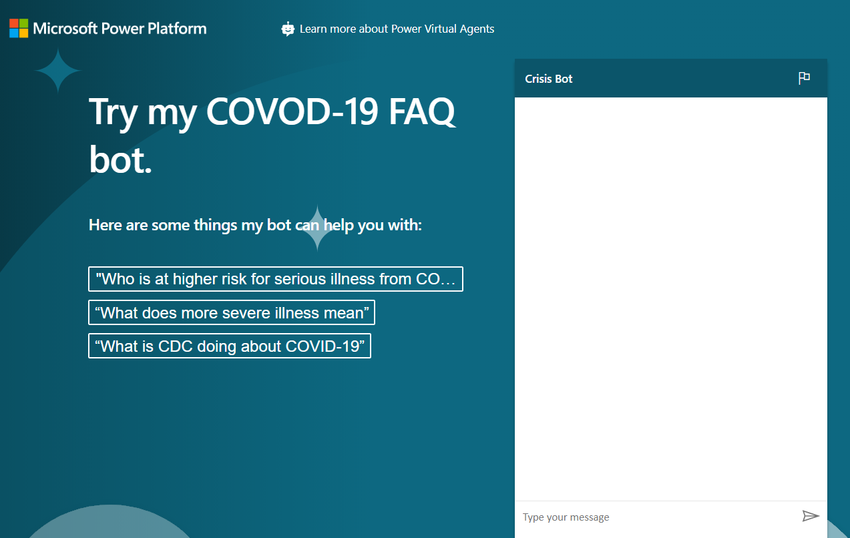

1. Go ahead and start chatting with the bot.

# Copyright

© 2020 Microsoft Corporation. All rights reserved.

By using this demo/lab, you agree to the following terms:

The technology/functionality described in this demo/lab is provided by Microsoft Corporation for purposes of obtaining your feedback and to provide you with a learning experience. You may only use the demo/lab to evaluate such technology features and functionality and provide feedback to Microsoft. You may not use it for any other purpose. You may not modify, copy, distribute, transmit, display, perform, reproduce, publish, license, create derivative works from, transfer, or sell this demo/lab or any portion thereof.

COPYING OR REPRODUCTION OF THE DEMO/LAB (OR ANY PORTION OF IT) TO ANY OTHER SERVER OR LOCATION FOR FURTHER REPRODUCTION OR REDISTRIBUTION IS EXPRESSLY PROHIBITED.

THIS DEMO/LAB PROVIDES CERTAIN SOFTWARE TECHNOLOGY/PRODUCT FEATURES AND FUNCTIONALITY, INCLUDING POTENTIAL NEW FEATURES AND CONCEPTS, IN A SIMULATED ENVIRONMENT WITHOUT COMPLEX SET-UP OR INSTALLATION FOR THE PURPOSE DESCRIBED ABOVE. THE TECHNOLOGY/CONCEPTS REPRESENTED IN THIS DEMO/LAB MAY NOT REPRESENT FULL FEATURE FUNCTIONALITY AND MAY NOT WORK THE WAY A FINAL VERSION MAY WORK. WE ALSO MAY NOT RELEASE A FINAL VERSION OF SUCH FEATURES OR CONCEPTS. YOUR EXPERIENCE WITH USING SUCH FEATURES AND FUNCTIONALITY IN A PHYSICAL ENVIRONMENT MAY ALSO BE DIFFERENT.

**FEEDBACK**. If you give feedback about the technology features, functionality and/or concepts described in this demo/lab to Microsoft, you give to Microsoft, without charge, the right to use, share and commercialize your feedback in any way and for any purpose. You also give to third parties, without charge, any patent rights needed for their products, technologies and services to use or interface with any specific parts of a Microsoft software or service that includes the feedback. You will not give feedback that is subject to a license that requires Microsoft to license its software or documentation to third parties because we include your feedback in them. These rights survive this agreement.

MICROSOFT CORPORATION HEREBY DISCLAIMS ALL WARRANTIES AND CONDITIONS WITH REGARD TO THE DEMO/LAB, INCLUDING ALL WARRANTIES AND CONDITIONS OF MERCHANTABILITY, WHETHER EXPRESS, IMPLIED OR STATUTORY, FITNESS FOR A PARTICULAR PURPOSE, TITLE AND NON-INFRINGEMENT. MICROSOFT DOES NOT MAKE ANY ASSURANCES OR REPRESENTATIONS WITH REGARD TO THE ACCURACY OF THE RESULTS, OUTPUT THAT DERIVES FROM USE OF DEMO/ LAB, OR SUITABILITY OF THE INFORMATION CONTAINED IN THE DEMO/LAB FOR ANY PURPOSE.

**DISCLAIMER**

This demo/lab contains only a portion of new features and enhancements in Microsoft Power Apps. Some of the features might change in future releases of the product. In this demo/lab, you will learn about some, but not all, new features.